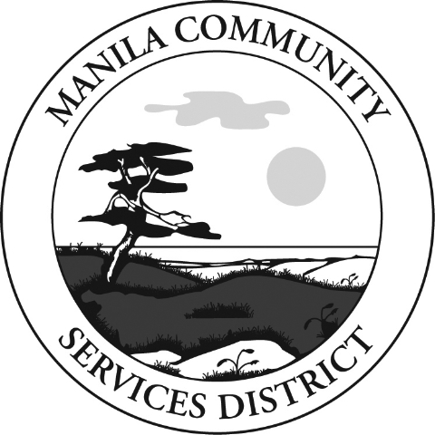🌊 Manila Community Services District

Welcome New Customers – Important Information

**💧 Current Rates**

* Sewer: Flat rate of $46.34 per month per residential unit.
* Water: Base rate of $41.57 per month + $2.08 per 100 cubic feet of water used.
* Meters are read between the 19th and 25th of each month.
* Customers are responsible for water use caused by leaks on their side of the meter.

**🧾 Billing Information**

* Bills are mailed the first business day of each month.
* Payments are due by the 20th of the same month.
* Late Fee: $10.00 for payments made after the due date.
* Shutoff for Nonpayment: Service may be discontinued without further notice.
* Reconnection requires all past due/current charges + disconnect fees + an additional deposit.
* Nonpayment Shutoff Fee: $40.00.
* Disconnect Fee (Customer Move-Out Without Notice): $40.00.
* Payment Options: ACH bank draft, E-billing, Online payments at www.manilacsd.com, or Office Drop slot (No Cash).

**🚨 Sewer System Information**

* Your property has a grey sewer control box. If the system alarms:
* • Call the District Office immediately: 707-444-3803
* • After Hours: 707-499-8451

**🌊 Tsunami Safety**

* Manila is located in a Tsunami Zone.
* Review evacuation routes and preparedness information at: www.manilacsd.com

**🏢 Office Hours**

* Monday – Friday: 9:00 a.m. – 1:00 p.m.
* After-Hours Payments: Drop slot available (No Cash).
* Phone: 707-444-3803 After Hours Emergencies: 707-499-8451

**📢 Stay Connected**

* Join the Manila Community Services District Facebook Page to receive updates on events, service alerts, and important announcements.